[Date]
[Tenant Name]
[Floor(s), and total square footage]
[Building Name/ Address]

Tenant Energy Optimization Summary

[Note: This tenant space energy-modeling template is a framework to be adjusted to the project-specific design and existing conditions.]

This report contains information provided as of [INSERT DRAWING SET AND DATE] and feedback from the architect, engineer (if model is not being built by project engineer), lighting designer, and tenant operations team. The model analyzes the impact of the energy performance measures (EPMs) listed below and determines tiers of energy performance packages based on the level of energy savings from including the following strategies:

Energy Performance Measures (EPMs) [List energy performance measures. Add numbers as necessary. Indicate which package each measure belongs to in the table below.]
- Lorem Ipsum
- Lorem Ipsum
- Lorem Ipsum
- Lorem Ipsum
- Lorem Ipsum
- Lorem Ipsum

Energy performance packages | Least energy reduction | Moderate energy reduction | Significant energy reduction
EPM 1 | • | • | •
EPM 2 |  | • | •
EPM 3 |  | • | •
EPM 4 |  | • | •
EPM 5 |  |  | •
EPM 6 |  |  | •

Energy Model

An energy model is being developed using the [eQUEST (DOE2.2, or identify other)] predictive computer modeling software. The features of the baseline building model are determined by the existing base building conditions at [insert building name/ location] and ASHRAE 90.1 2007 code requirements. Improvements to this model are then made to assess energy efficiency design improvements to the systems of the leased premises.

[Describe the tenant design standards or business-as-usual design as the adjusted baseline.]
[Describe buildout phases if the project is a multifloor tenant space and how the design scope differs in each phase, if applicable.]

Energy Utility Rates

Utility rates have been based on [note year of collected utility bills, ideally last full year before analysis].
Electric costs used a blended rate of [$0.XX/kWh], which includes average annual base rate and demand charges.
Steam costs were modeled per [note applicable utility company and insert utility table below] as shown in the table below. Note that any steam savings or penalties have been assumed to be absorbed by the owner because of the negotiated rate of the steam costs to the tenant (if applicable).

Modeled [utility company] steam rates |  |  | Previous published year
On-peak-demand charge  All-time-peak-demand charge |  | $/Mlb/hr  $/Mlb/hr | $/Mlb/hr  $/Mlb/hr
Summer steam consumption  All additional Mlbs (already includes GRT, taxes) |  | $/Mlb | $/Mlb
Winter steam consumption  All additional Mlbs (already includes GRT, taxes) |  | $/Mlb | $/Mlb
Swing steam consumption  All additional Mlbs (already includes GRT, taxes) |  | $/Mlb | $/Mlb
GRT taxes  State and city taxes |  | %  % | %  %
Natural gas costs are estimated to be [$X.XX/therm].

Energy Model Assumptions (to be adjusted/confirmed by the tenant and/or design team):

Condition [Revise as applicable. Example below is illustrative.] | Confirmation / Comment
The number of people on the floor is estimated as 200 gross square feet (including storage and corridors, but excluding unconditioned core) per person, a typical value for this type of office space.
On a typical day, only 95% of the maximum occupancy will be present and working on the floor. Lower occupancy is typically because of offsite meeting, absences, and travel. For example, floor 14 is estimated as having maximum design occupancy of 86 people but a typical day maximum occupancy of 82 people.
The space ends occupancy at 7 p.m., with a few people staying until 8 p.m.
Most lights are turned on at 7 a.m. and off at 7 p.m.
On a typical day, 90% of the installed lighting is turned on (ignoring daylight harvesting controls but including occupancy sensors).

Preliminary Results
The design (noted above) was evaluated from the perspective of energy efficiency opportunities. Areas of high efficiency in the current design are noted as well as areas with potential for further increasing the energy efficiency of tenant improvements.

The preliminary energy model estimates that the optimal package will yield approximately X% in annual tenant space electric energy cost savings relative to the existing baseline conditions at [insert building name/ location].

Note that savings will also affect the owner for central plant–related energy, including chilled water, pumping, and cooling tower fans and are noted in the following table. Tenant savings will primarily correspond to lights, plug-in equipment loads, and ventilation fans. Any steam related savings or penalties have been assumed to be absorbed by the owner, because of the negotiated rate of the steam costs to the tenant (if applicable).

 | Phase I floor(s)  tenant | Phase II floor(s)  tenant | Phase III floor(s)  tenant | Building owner
Baseline energy use (kWh)
Energy reduction (kWh) (%)
Energy use intensity (W/SF)
Lighting power density (W/SF)
Energy use per person (kWh/person/year)

Space type | Tenant premises
Project area | XX square feet
Conference | %
Corridor | %
Mechanical/electrical | %
Office | %
Other | %
Restroom | %
Storage | %
Description of Tenant-Driven EPMs: [Insert language related to energy performance measures. Examples below are illustrative.]
Envelope

Note: Include all energy capital improvements completed or planned by the building owner for an adjusted baseline.

Perimeter Wall Insulation

Adding insulation to the exterior walls reduces thermal heat transfer of the surface, resulting in decreased heat gain in the perimeter spaces of the building. This measure assumes that R-20 insulation will be added to the inside of the perimeter walls. Assume aerogel wall insulation will be added to the premises before the perimeter wall enclosure and finish (white box).

Window Film

Using a film on the existing glazing is one way to control solar heat gain through the glass. The baseline glass has a U-Value of 0.60 and a Solar Heat Gain Coefficient (SHGC) of 0.70. Using a film would reduce the SHGC to 0.50. This run in the analysis has assumed that film would be used for levels 16–21 as part of the tenant buildout.

Window Replacement/Retrofit

Replacing the existing glass with a higher-efficiency glass would also provide energy savings associated with the reduced solar load and increased glazing insulation. The baseline glass has a U-Value of 0.60 and an SHGC of 0.70. The replacement glass has been assumed to have a U-Value of 0.167 and an SHGC of 0.40.

Lighting Load Reduction
Daylighting Dimming/Harvesting Controls

Total annual energy savings: XX kWh
Tenant annual energy savings: XX kWh (X%)
Building owner annual energy savings: XX kWh (X%)

High-Efficiency LED Lighting

The use of a high-efficiency lighting layout with occupancy sensors in the open office plan areas for future tenants will provide energy savings relative to a baseline whole-building allowance of X.X watts per square foot.

Total annual energy savings: XX kWh
Tenant annual energy savings: XX kWh (X%)
Building owner annual energy savings: XX kWh (X%)

Plug-In Equipment Load Reduction
Plug-Load Control: Computer Software
Specialized computer software automatically backs up computers and shuts down computers to save energy during unoccupied periods. This analysis assumes that the use of the computer power control software combined with the off-hours plug load controlling the plug-in equipment, loads will be reduced by 50 percent during unoccupied hours.

Total annual energy savings: XX kWh
Tenant annual energy savings: XX kWh (X%)
Building owner annual energy savings: XX kWh (X%)

Plug-Load Control: Occupancy Sensors

Typically, plug loads are reduced at night, but not to zero. Many plug loads continue to draw power, at a reduced rate, when they are in sleep or off mode. One approach to minimizing these phantom loads is to provide some number of outlets with active control that turns off power completely when the space is unoccupied. This analysis assumes that plug-in equipment will be reduced by 10 percent during occupied hours, and combined with the Night Watchman controls will reduce plug-in equipment loads by 50 percent during unoccupied hours.

Total annual energy savings: XX kWh
Tenant annual energy savings: XX kWh (X%)
Building owner annual energy savings: XX kWh (X%)

Plug Load Control: Kill Switch

Total annual energy savings: XX kWh
Tenant annual energy savings: XX kWh (X%)
Building owner annual energy savings: XX kWh (X%)

Server Equipment/IT Network Optimization

The implementation of the measure may be a combination of specifying Energy Star servers and rightsizing server equipment, virtualization, and data distribution technologies such as a passive optical network. The reduction in electrical use would result in savings from the equipment power load as well as reduced computer room air conditioning and cooling load. A comprehensive design study would be needed to investigate the design and implications of the measure.

High-Efficiency Servers

Existing building server and IT loads have been estimated for the intermediate distribution frame and main distribution frame rooms as 30–50 watts per square foot. Use of high-efficiency server equipment could reduce these loads significantly. This analysis assumes that IT loads have been reduced by 50 percent as part of the tenant buildout.

Total annual energy savings: XX kWh
Tenant annual energy savings: XX kWh (X%)
Building owner annual energy savings: XX kWh (X%)

Heating/Ventilation/Air Conditioning (HVAC) Optimization

Rightsizing variable air volume air handling units (AHUs)
Low-velocity AHUs
Variable frequency drives on AHUs
Noise filter elimination on AHUs
Air distribution duct layout (may include bridged after-hours supplemental cooling, air resistance reduction with elbows)

Total annual energy savings: XX kWh
Tenant annual energy savings: XX kWh (X%)
Building owner annual energy savings: XX kWh (X%)

Appendix A: Original and Calibrated Energy Model Results for Tenant Electricity [Appendices are illustrative; actual model results should be included.]

Original Model Results

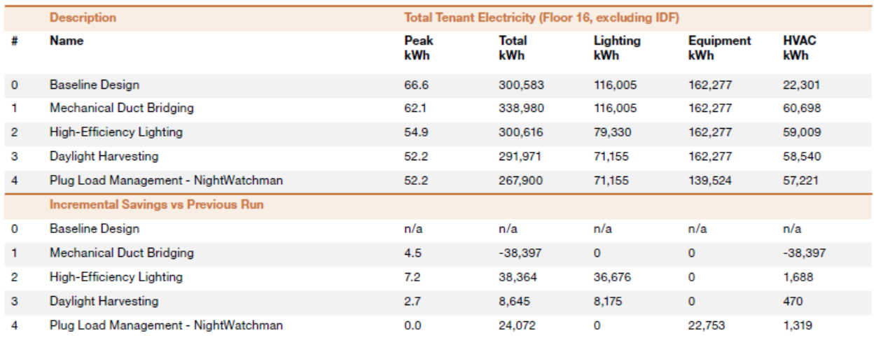
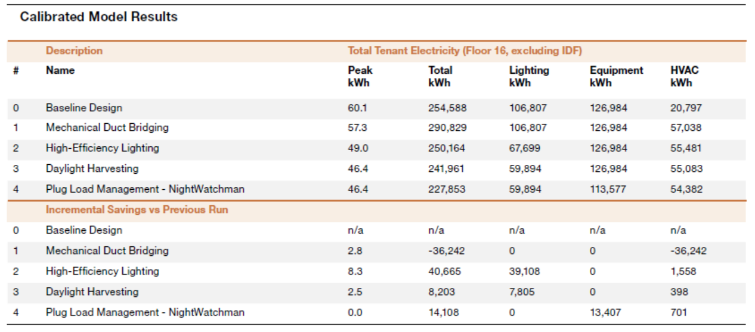
Appendix B: Original and Final Energy Model Results for Tenant Electricity

Energy Model Output by Measure

